**IBM Cloud Computing**

**Name : Monisha A**

**Register no : 822721104030**

**Technology : Cloud Application Development**

**Project Name : Personal Blog on IBM cloud Static Web Apps**

**Theme : Personal Food Blog**

**PHASE-1:**

**Design and Thinking:**

* **The project is to create a personal food blog hosted on IBM Cloud Static Web Apps**

* **The goal is to share food journalism interlinking a gourmet interest in food ,tips ,food photography .**
* **Our Food Blog can be about the cuisine of different cultures and offer readers a way to access delicious receipes and kitchen tips without having to shell out for a cookbook or make a call to a relative for help.**

**Content Planning:**

* **Plan the blogs Structure , including sections for foods stories ,Eco -friendly tips , photos and possibly a map showing the restaurants places**

**Content Creation:**

* **Writing about the latest food trends, like plant-based eating or air fryer recipes.**

**Website Design:**

* **Design an aesthetically pleasing and user-friendly layout for the blog using HTML,CSS and Possibly JavaScript for interactive elements.**

**IBM Cloud Setup:**

* **Set up an account on IBM Cloud and create a Static Web App to host the blog.**

**Content Management:**

* **Choose a suitable Content Management System(CMS) or Static site generator to make it easy to update and manage it.**

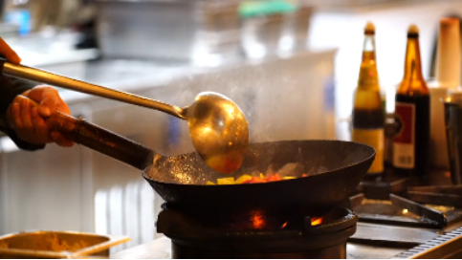

**PHASE-2**

**INNOVATION:**

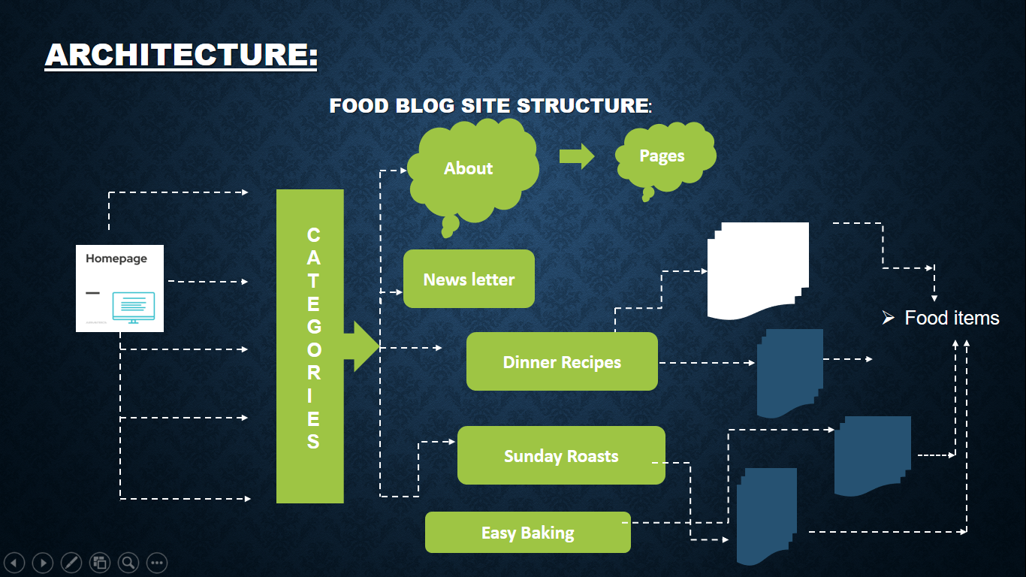

**My Food Blog innovation:Tamilians and hospitality-Inseparable**

* **Plastic-free and Smart Packing**
* **Drinks that Offer More**
* **Advanced Computerized Technology**

**Modernization of Old Processing Technique**

* **A focus on Transparency and Trush**
* **The Use of Forward Osmosis**
* **Plant-based,Animal-free Products**
* **Freeze Drying**
* **Alternative Proteins**
* **Personalized Nutrition**
* **Vertical Farming**
* **Blockchain in Agri-Food and Banana Leaves Supply**
* **Secret behind Tranditional Tamil Foods Served on Banana Leaves.**
* **14.Foods are cooked only in manpaanai**
* **15.The Resurrection of the QR code in food packing**
* **16.A Return to old food processing Technique**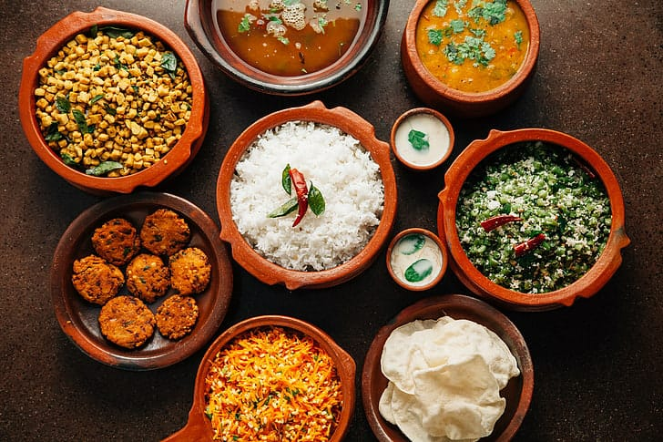

**Some Traditional Foods:** 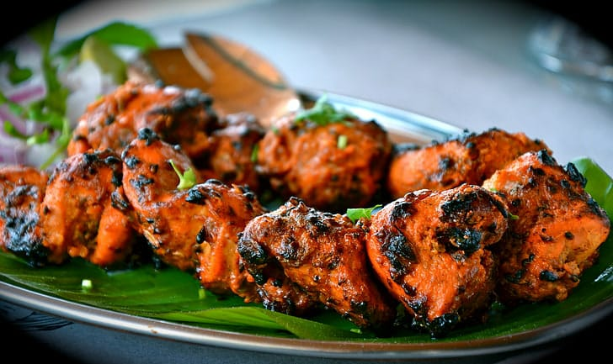

* **Uttapam-the fluffy pancake** 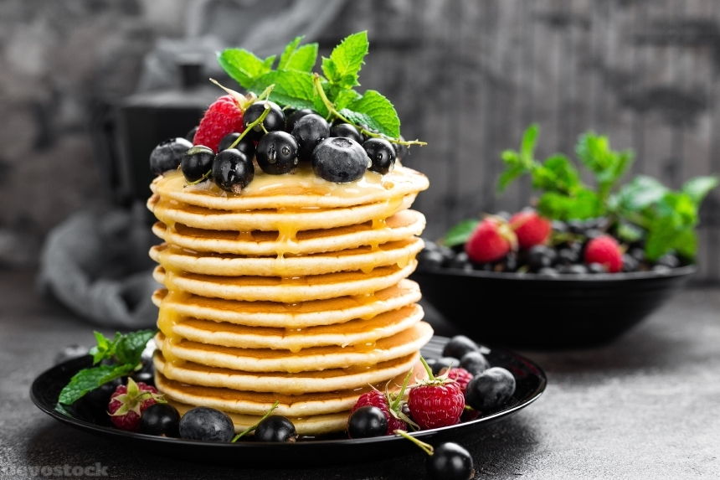
* **Chicken chettinad**

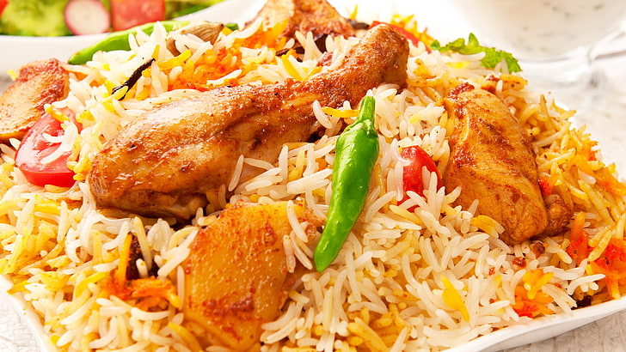

* **Banana Bonda**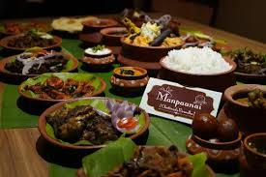
* **Idiyappam paaya**
* **Paniyaram**

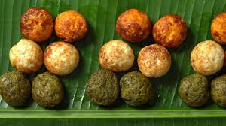

* **Rava vadai**

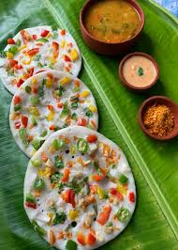

* **Sukku malli coffee**
* **Prawns Kuzhambu**

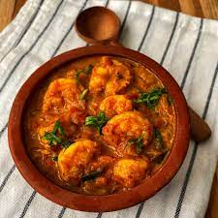

**PHASE-3:**

**DEVELOPMENT PART-1**

**INTRODUCTION:**

**Our Personal Food Blog is about traditional foods of Tamilnadu and Hospitality of Tamilians.Our blog for development part1 is a review of western restaurant in Tamilnadu.First We review a western foods.Then we can find a relevant traditional foods of those recipes in next phase(Phase4).**

**WEBSITE DEVELOPMENT:**

**HTML CODE:**

<!DOCTYPE html>

<html lang="en">

<head>

    <meta charset="UTF-8">

    <meta name="viewport" content="width=device-width, initial-scale=1.0">

    <title>My Food Blog</title>

    <link rel="stylesheet" href="style.css">

</head>

<body>

    <header>

        <h1>Welcome to My Personal Food Blog</h1>

    </header>

    <nav>

        <ul>

            <li><a href="#">Home</a></li>

            <li><a href="#">Places</a></li>

            <li><a href="#">Blog</a></li>

            <li><a href="#">About</a></li>

            <li><a href="#">Contact</a></li>

        </ul>

    </nav>

    <main>

        <section id="featured">

            <h2>Suggested Restaurant</h2>

            <article>

                <img src="freddo.webp" alt="Freddo Bistro">

                <h3>Freddo Bistro</h3>

                <p>Nestled amidst the tranquil embrace of nature, our restaurant offers a unique dining experience like no other. Surrounded by lush greenery and framed by serene landscapes, our establishment is a hidden gem located just beyond the bustling city. Step into a world where the symphony of birdsong accompanies your meal, and the rustling leaves provide the perfect backdrop to savor our delectable cuisine. Whether you're seated on our open-air terrace or in our cozy indoor dining area, you'll be transported to a realm of culinary delight while being one with the natural beauty that envelopes us. Our menu, inspired by the bounties of the earth, showcases a fusion of flavors that reflect the harmony of the surroundings. Come and dine with us for an unforgettable journey that celebrates both the senses and the splendor of the great outdoors.</p>

                <a href="#">Read More</a>

            </article>

        </section>

        <section id="blog">

            <h2>THE DELICIOUS RECIPES OF FREDDO</h2>

            <h2>Signature Beverages</h2>

            <article>

                <img src="beverage.jpg" alt="Nearby places">

                <h3>BEVERAGES</h3>

                <ul>

                    <li>Pink Milk</li>

                    <li>Americano</li>

                    <li>Mocca</li>

                    <li>Black Cocoa</li>

                </ul>

                <a href="#">Read More</a>

            </article>

            <!-- More blog posts go here -->

        </section>

        <section id="blog">

            <h2>Signature Stuffings</h2>

            <article>

                <img src="spicy.jpg" alt="Spicy stuffins">

                <h3>Spicy Stuffings</h3>

                <ul>

                    <li>Aussi Burger</li>

                    <li>Potato Spicy Wedges </li>

                    <li>French Onion Soup</li>

                    <li>Scallop Bacon</li>

                </ul>

                <a href="#">Read More</a>

            </article>

            <!-- More blog posts go here -->

        </section>

    </main>

    <footer>

        <p>&copy; 2023 My Food Blog</p>

    </footer>

</body>

</html>

**CSS CODE:**

/* Reset some default browser styles */

body, h1, h2, ul, li, p, article {

    margin: 0;

    padding: 0;

}

body {

    font-family: 'Arial', sans-serif;

    background-color: #f0f0f0;

}

header {

    background-image: url('header-background.jpg');

    background-size: cover;

    background-position: center;

    color:black;

    text-align: center;

    padding: 100px 0;

}

nav ul {

    list-style-type: none;

    background-color: #333;

    text-align: center;

    padding: 10px 0;

}

nav li {

    display: inline;

    margin-right: 20px;

}

nav a {

    text-decoration: none;

    color: #fff;

    font-weight: bold;

    transition: color 0.3s;

}

nav a:hover {

    color: #ff5733; /* Change to your preferred hover color */

}

main {

    max-width: 900px;

    margin: 20px auto;

    padding: 20px;

    background-color: #fff;

    box-shadow: 0px 0px 20px rgba(0, 0, 0, 0.1);

}

section h2 {

    font-size: 28px;

    margin-bottom: 20px;

    text-align: center;

}

article {

    margin-bottom: 40px;

    padding: 20px;

    background-color: #f9f9f9;

    border: 1px solid #ddd;

    box-shadow: 0px 0px 10px rgba(0, 0, 0, 0.1);

    transition: transform 0.3s;

}

article:hover {

    transform: scale(1.03); /* Add a subtle hover effect */

}

article img {

    max-width: 100%;

    height: auto;

    border-radius: 5px;

}

article h3 {

    font-size: 24px;

    margin: 10px 0;

}

footer {

    text-align: center;

    background-color: #333;

    color: #fff;

    padding: 10px;

    font-size: 18px;

}

**PHASE-4**

**DEVELOPMENT PART-2**

**INTRODUCTION:**

**Our Personal Food Blog is about traditional foods of Tamilnadu & Kerala and Hospitality of Tamilians.Our blog for development part2 is a traditional foods of some particular familiar places in India. We discuss about both viewable places and best traditional restaurant in their nearby places.**

**WEBSITE DESIGN CODE:**

**HOME PAGE:**

<!DOCTYPE html>

<html lang="en">

<head>

    <meta charset="UTF-8">

    <meta name="viewport" content="width=device-width, initial-scale=1.0">

    <title>My Food Blog</title>

    <link rel="stylesheet" href="styles.css">

</head>

<body>

    <header>

        <h1>My FOOD Blog</h1>

        <nav>

          <ul>

              <li><a href="index.html">Home</a></li>

<li><a href="destinations.html">Destinations</a></li>

              <li><a href="blog.html">Blog</a></li>

              <li><a href="about.html">About</a></li>

              <li><a href="contact.html">Contact</a></li>

          </ul>

      </nav>

    </header>

    <section class="hero">

        <h2>Explore the World With FOOD</h2>

        <p>Discover amazing places, cultures, and adventures around the globe with their traditional foods</p>

        <a href="#" class="btn">Get Started</a>

    </section>

    <section class="featured-destinations">

        <h2>Featured Destinations</h2>

        <div class="destination">

<img src="chettinadu.jpg" alt="Chettinadu,Karaikudi">

          <h3>Chettinadu,Karaikudi</h3>

          <p>Experience the treasure of Chettinadu.</p>

      </div>

      <div class="destination">

          <img src="kumbakonam.jpg" alt="kumbakonam">

          <h3>Kumbakonam,Thanjavur</h3>

          <p>Discover the vibrant culture and temples of Kumbakonam.</p>

      </div>

      <div class="destination">

          <img src="azhapula.jpg" alt="Azhapula">

          <h3>Alappuzha,Kerala</h3>

          <p>Relax on the beautiful view of kerala.</p>

      </div>

    </section>

    <section class="latest-posts">

        <h2>Latest Posts</h2>

        <div class="post">

<img src="chetti_food.jpg" alt="Exploring the food">

          <h3>Exploring the foods of Chettinadu</h3>

      </div>

      <div class="post">

          <img src="degree.jpg" alt="degree">

          <h3>Taste Degree Coffee Of Kumbakonam</h3>

      </div>

    </section>

    <footer>

        <p>&copy; 2023 My Food Blog</p>

    </footer>

</body>

</html>

<style>

  /* Reset some default styles */

body, h1, h2, h3, p {

    margin: 0;

    padding: 0;

}

/* Basic styling */

body {

    font-family: Arial, sans-serif;

    background-color: #f2f2f2;

}

header {

    background-color: #333;

    color: #fff;

    padding: 20px 0;

    text-align: center;

}

header h1 {

    font-size: 36px;

    margin-bottom: 10px;

}

nav ul {

    list-style: none;

}

nav ul li {

    display: inline;

    margin-right: 20px;

}

nav a {

    color: #fff;

    text-decoration: none;

}

.hero {

    text-align: center;

    padding: 50px 0;

}

.hero h2 {

    font-size: 36px;

    margin-bottom: 10px;

}

.btn {

    display: inline-block;

    padding: 10px 20px;

    background-color: #333;

    color: #fff;

    text-decoration: none;

    border-radius: 5px;

}

.featured-destinations {

    text-align: center;

    padding: 50px 0;

}

.destination {

    margin: 20px;

    padding: 20px;

    background-color: #fff;

    border-radius: 5px;

}

.destination h3 {

    font-size: 24px;

    margin-top: 10px;

}

.latest-posts {

    text-align: center;

    padding: 50px 0;

}

.post {

    margin: 20px;

    padding: 20px;

    background-color: #fff;

    border-radius: 5px;

}

.post h3 {

    font-size: 24px;

    margin-top: 10px;

}

footer {

    text-align: center;

    padding: 10px 0;

    background-color: #333;

    color: #fff;

}

</style>

**DESTINATIONS:**

<!DOCTYPE html>

<html lang="en">

<head>

    <meta charset="UTF-8">

    <meta name="viewport" content="width=device-width, initial-scale=1.0">

    <title>Destinations - My FOOD Blog</title>

    <link rel="stylesheet" href="styles.css">

</head>

<body>

    <header>

        <h1>My Food Blog</h1>

        <nav>

            <ul>

                <li><a href="index.html">Home</a></li>

                <li><a href="destinations.html">Destinations</a></li>

                <li><a href="blog.html">Blog</a></li>

                <li><a href="about.html">About</a></li>

                <li><a href="contact.html">Contact</a></li>

</ul>

        </nav>

    </header>

    <section class="destinations">

        <h2>Explore Our Featured Destinations</h2>

        <div class="destination">

            <img src="degree-coffee.webp" alt="Kumbakonam">

            <h3>Kumbakonam Degree Coffee,Kumbakonam</h3>

            <p>Experience the delicious coffee in the world.</p>

        </div>

        <div class="destination">

            <img src="chidambara.jpg" alt="Chettinadu">

            <h3>Chidambara Vilas,Chettinadu</h3>

            <p>Traditional Food Of Chettinadu.</p>

        </div>

        <div class="destination">

            <img src="Choola.jpg" alt="Alappuzha">

            <h3>Alappuzha,Kerala</h3>

            <p>Relax on the beautiful view of Alappuzha with delicious cuisine.</p>

        </div>

    </section>

    <!-- Additional destinations can be added here -->

    <footer>

        <p>&copy; 2023 My Food Blog</p>

    </footer>

</body>

</html>

<style>

    /* Reset some default styles */

body, h1, h2, h3, p {

    margin: 0;

    padding: 0;

}

/* Basic styling */

body {

    font-family: Arial, sans-serif;

background-color: #f2f2f2;

}

header {

    background-color: #333;

    color: #fff;

    padding: 20px 0;

    text-align: center;

}

header h1 {

    font-size: 36px;

    margin-bottom: 10px;

}

nav ul {

    list-style: none;

}

nav ul li {

    display: inline;

    margin-right: 20px;

}

nav a {

    color: #fff;

    text-decoration: none;

}

.destinations {

    text-align: center;

    padding: 50px 0;

}

.destinations h2 {

    font-size: 36px;

    margin-bottom: 20px;

}

.destination {

    margin: 20px;

    padding: 20px;

    background-color: #fff;

    border-radius: 5px;

    box-shadow: 0 0 10px rgba(0, 0, 0, 0.1);

}

.destination img {

max-width: 100%;

    border-radius: 5px;

}

.destination h3 {

    font-size: 24px;

    margin-top: 10px;

}

.destination p {

    margin-top: 10px;

}

footer {

    text-align: center;

    padding: 10px 0; background-color: #333;

    color: #fff;}

</style>

**BLOG:**

<!DOCTYPE html>

<html lang="en">

<head>

    <meta charset="UTF-8">

    <meta name="viewport" content="width=device-width, initial-scale=1.0">

    <title>Blog - My FOOD Blog</title>

    <link rel="stylesheet" href="styles.css">

</head>

<body>

    <header>

        <h1>My Travel Blog</h1>

        <nav>

            <ul>

                <li><a href="index.html">Home</a></li>

                <li><a href="destinations.html">Destinations</a></li>

                <li><a href="blog.html">Blog</a></li>

                <li><a href="about.html">About</a></li>

                <li><a href="contact.html">Contact</a></li>

            </ul>

        </nav>

    </header>

<section class="blog">

        <h2>Latest Blog Posts</h2>

        <div class="post">

            <img src="dining_cheeti.webp" alt="Post 1">

            <h3>Exploring the Traditional Food Of Chettinadu</h3>

            <p>Chettinad cuisine is renowned for its rich, spicy, and flavorful dishes that are a hallmark of the Chettinad region in Tamil Nadu, South India. The cuisine is known for its use of a wide range of spices and fresh ingredients, resulting in a distinctive and aromatic flavor profile.</p>

        </div>

        <div class="post">

            <img src="sadya.jpg" alt="Post 2">

            <h3>Exploring the traditional foods of Kerala</h3>

            <p>Rice and Coconut: Rice is the staple food of Kerala, and it is often accompanied by a variety of coconut-based dishes. Coconut is a fundamental ingredient and is used in various forms, including grated coconut, coconut milk, and coconut oil.

                Sadhya: A traditional Kerala feast called "Sadhya" is a grand vegetarian meal served on a banana leaf. It typically includes a wide array of dishes, including rice, sambar (a lentil-based vegetable stew), rasam (a spiced tamarind soup), avial (a mixed vegetable dish in coconut sauce), and various side dishes.</p>

        </div>

    </section>

    <!-- Additional blog posts can be added here -->

    <footer>

        <p>&copy; 2023 My Food Blog</p>

    </footer>

</body>

</html>

<style>

    /* Reset some default styles */

body, h1, h2, h3, p {

    margin: 0;

    padding: 0;

}

/* Basic styling */

body {

    font-family: Arial, sans-serif;

    background-color: #f2f2f2;

}

header {

    background-color: #333;

    color: #fff;

    padding: 20px 0;

    text-align: center;

}

header h1 {

    font-size: 36px;

    margin-bottom: 10px;

}

nav ul {

    list-style: none;

}

nav ul li {

    display: inline;

    margin-right: 20px;

}

nav a {

    color: #fff;

    text-decoration: none;

}

.blog {

    text-align: center;

    padding: 50px 0;

}

.blog h2 {

    font-size: 36px;

    margin-bottom: 20px;

}

.post {

    margin: 20px;

padding: 20px;

    background-color: #fff;

    border-radius: 5px;

    box-shadow: 0 0 10px rgba(0, 0, 0, 0.1);

}

.post img {

    max-width: 100%;

    border-radius: 5px;

}

.post h3 {

    font-size: 24px;

    margin-top: 10px;

}

.post p {

    margin-top: 10px;

}

footer {

    text-align: center;

    padding: 10px 0;

    background-color: #333;

    color: #fff;

}

</style>

**ABOUT:**

<!DOCTYPE html>

<html lang="en">

<head>

    <meta charset="UTF-8">

    <meta name="viewport" content="width=device-width, initial-scale=1.0">

    <title>About - My FOOD Blog</title>

    <link rel="stylesheet" href="styles.css">

</head>

<body>

    <header>

        <h1>My Food Blog</h1>

        <nav>

            <ul>

                <li><a href="index.html">Home</a></li>

<li><a href="destinations.html">Destinations</a></li>

                <li><a href="blog.html">Blog</a></li>

                <li><a href="about.html">About</a></li>

                <li><a href="contact.html">Contact</a></li>

            </ul>

        </nav>

    </header>

    <section class="about">

        <h2>About Us</h2>

        <p>Welcome to My food Blog! We're passionate about exploring the world of food and sharing our experiences with you. Our goal is to inspire and help you plan your next dining.</p>

    </section>

    <footer>

        <p>&copy; 2023 My Food Blog</p>

    </footer>

</body>

</html>

<style>

    /* Reset some default styles */

body, h1, h2, p {

    margin: 0;

    padding: 0;

}

/* Basic styling */

body {

    font-family: Arial, sans-serif;

    background-color: #f2f2f2;

}

header {

    background-color: #333;

    color: #fff;

    padding: 20px 0;

    text-align: center;

}

header h1 {

    font-size: 36px;

margin-bottom: 10px;

}

nav ul {

    list-style: none;

}

nav ul li {

    display: inline;

    margin-right: 20px;

}

nav a {

    color: #fff;

    text-decoration: none;

}

.about {

    text-align: center;

    padding: 50px 0;

}

.about h2 {

    font-size: 36px;

    margin-bottom: 20px;

}

.about p {

    max-width: 600px;

    margin: 0 auto;

    padding: 0 20px;

}

footer {

    text-align: center;

    padding: 10px 0;

    background-color: #333;

    color: #fff;

}

</style>

**CONTACT:**

<!DOCTYPE html>

<html lang="en">

<head>

    <meta charset="UTF-8">

    <meta name="viewport" content="width=device-width, initial-scale=1.0">

    <title>Contact - My FOOD Blog</title>

    <link rel="stylesheet" href="styles.css">

</head>

<body>

    <header>

        <h1>My Food Blog</h1>

        <nav>

            <ul>

                <li><a href="index.html">Home</a></li>

                <li><a href="destinations.html">Destinations</a></li>

                <li><a href="blog.html">Blog</a></li>

                <li><a href="about.html">About</a></li>

                <li><a href="contact.html">Contact</a></li>

            </ul>

        </nav>

    </header>

    <section class="contact">

        <h2>Contact Us</h2>

        <p>Have questions or feedback? Feel free to get in touch with us.</p>

        <form>

            <label for="name">Name</label>

            <input type="text" id="name" name="name" placeholder="Your name">

            <label for="email">Email</label>

            <input type="email" id="email" name="email" placeholder="Your email">

            <label for="message">Message</label>

            <textarea id="message" name="message" placeholder="Your message"></textarea>

            <button type="submit">Submit</button>

        </form>

    </section>

    <footer>

<p>&copy; 2023 My Food Blog</p>

    </footer>

</body>

</html>

<style>

    /* Reset some default styles */

body, h1, h2, p, form, label, input, textarea, button {

    margin: 0;

    padding: 0;

    box-sizing: border-box;

}

/* Basic styling */

body {

    font-family: Arial, sans-serif;

    background-color: #f2f2f2;

}

header {

    background-color: #333;

    color: #fff;

    padding: 20px 0;

    text-align: center;

}

header h1 {

    font-size: 36px;

    margin-bottom: 10px;

}

nav ul {

    list-style: none;

}

nav ul li {

    display: inline;

    margin-right: 20px;

}

nav a {

    color: #fff;

    text-decoration: none;

}

.contact {

    text-align: center;

    padding: 50px 0;

}

.contact h2 {

    font-size: 36px;

    margin-bottom: 20px;

}

.contact p {

    margin-bottom: 20px;

}

form {

    max-width: 500px;

    margin: 0 auto;

}

label, input, textarea, button {

    display: block;

    margin-bottom: 20px;

}

label {

    font-weight: bold;

}

input, textarea {

    width: 100%;

    padding: 10px;

    border: 1px solid #ccc;

    border-radius: 5px;

}

button {

    background-color: #333;

    color: #fff;

    padding: 10px 20px;

    border: none;

    border-radius: 5px;

    cursor: pointer;

}

footer {

    text-align: center;

    padding: 10px 0;

    background-color: #333;

    color: #fff;

}

</style>

**OUTPUT:**

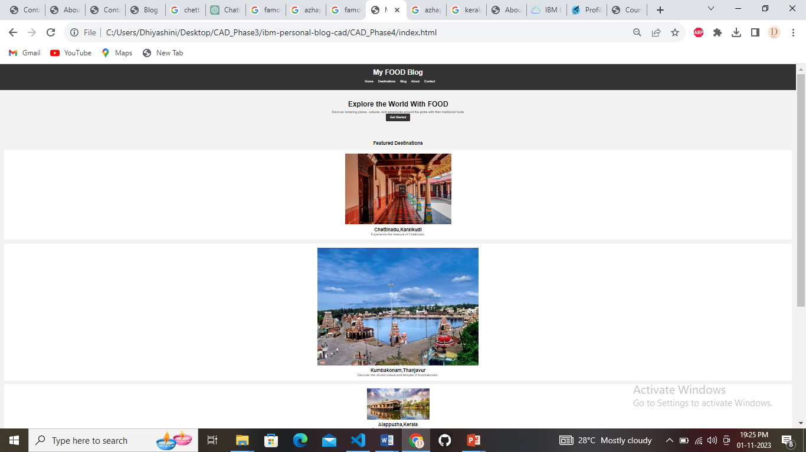

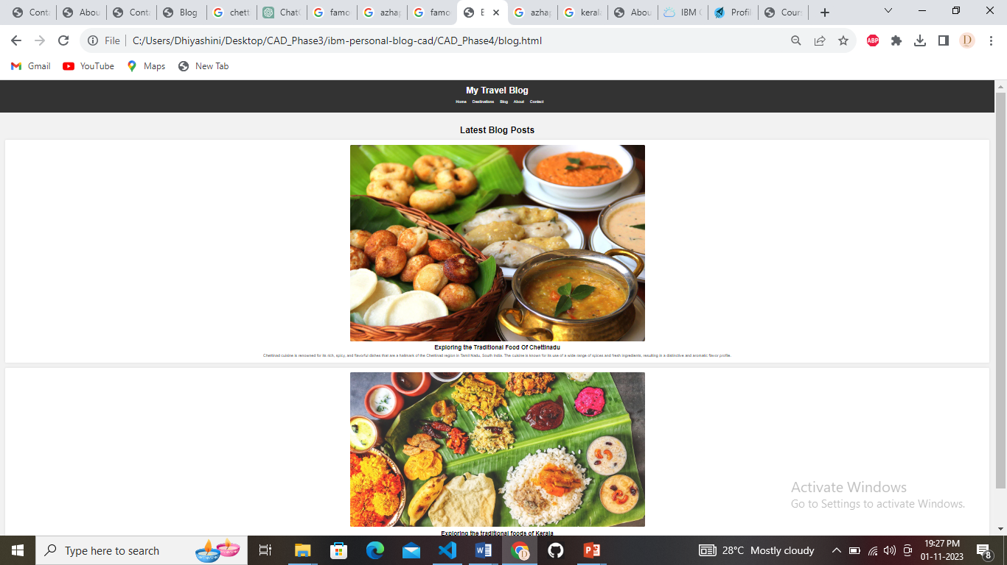

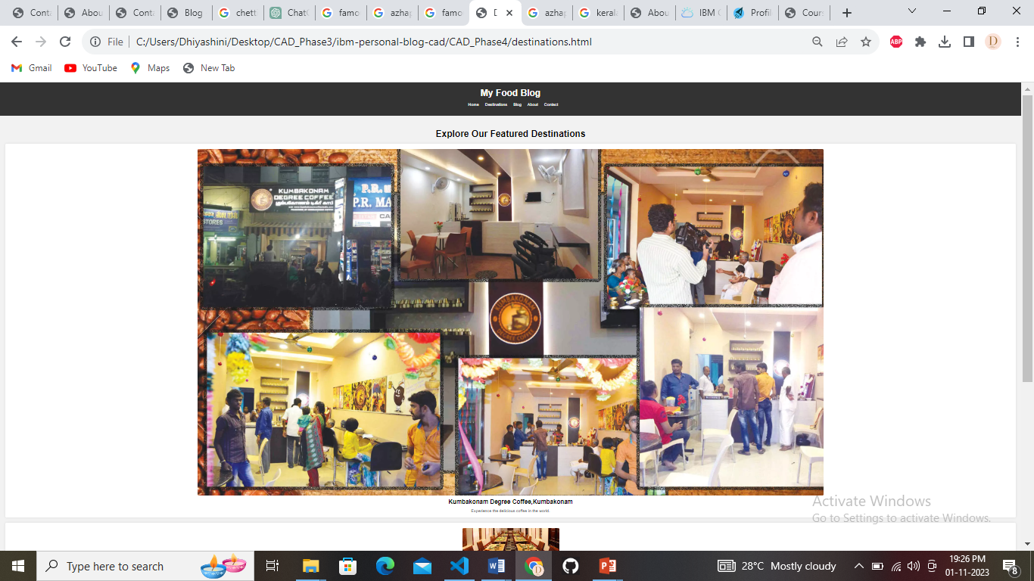

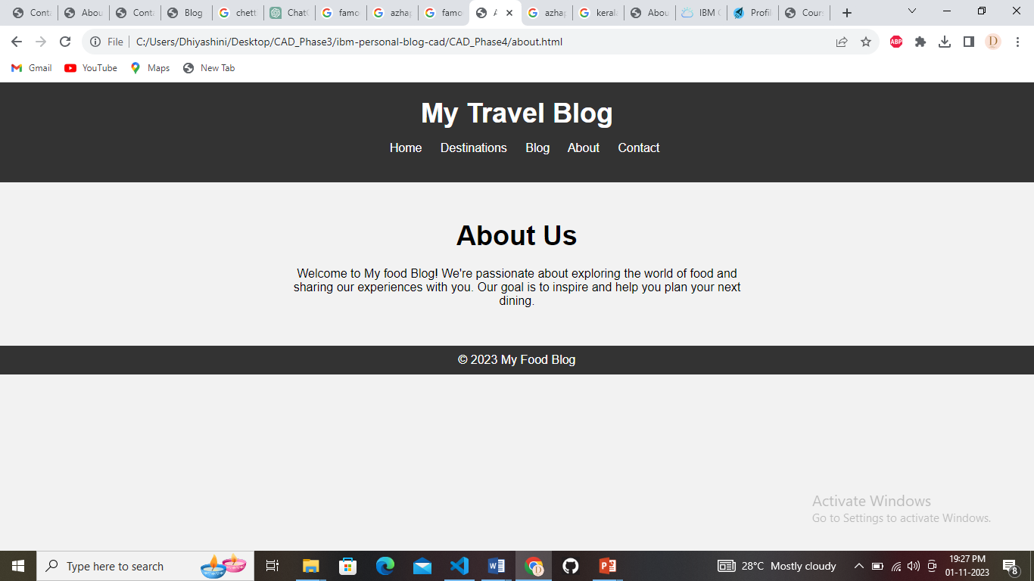

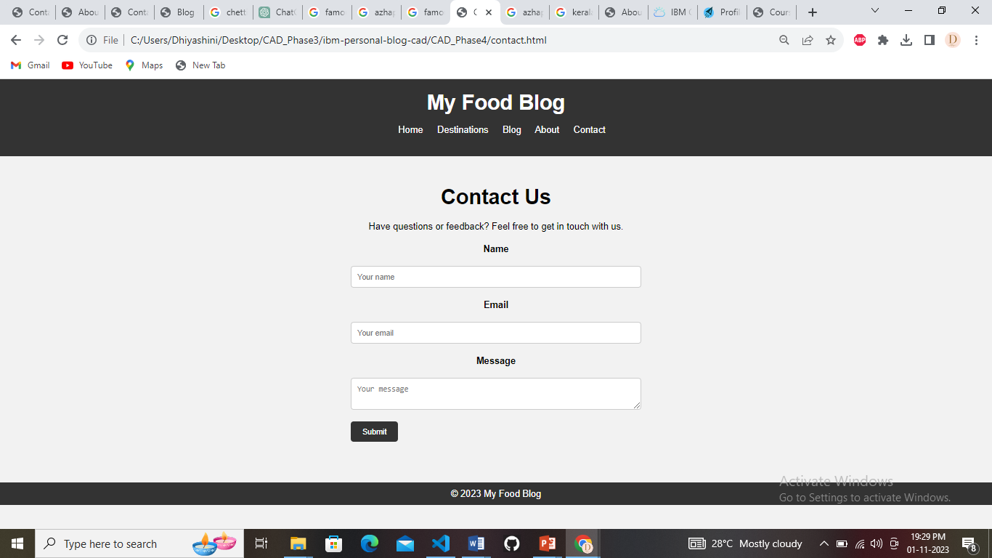

**THANK YOU**